**Name :Darshan.B**

**Email ID :** v.b.darshan200128@gmail.com

**Day 4 Assignment (Cyber Security Essentials)**

**Solution :**

**Q1) Find out the mail servers of the following domain:**

* **Ibm.com**
* **Wipro.com**

Open -> PenTester VMware workstation

Open -> Command Prompt

***Type***

* ipconfig
* nslookup
* [www.Ibm.com](http://www.Ibm.com)

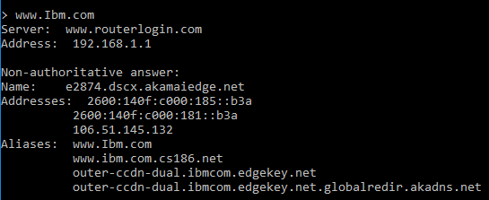

v.b.darshan200128@gmail.com

* [www.Wipro.com](http://www.Wipro.com)

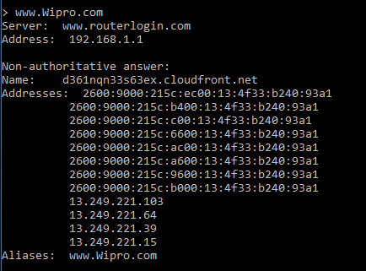

**Q2) Find the locations, where these email servers are hosted.**

***Type***

* set type=mx
* Ibm.com

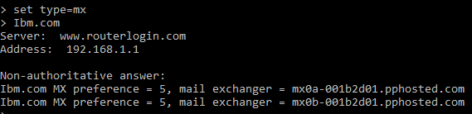

v.b.darshan200128@gmail.com

**Location**

Address 1

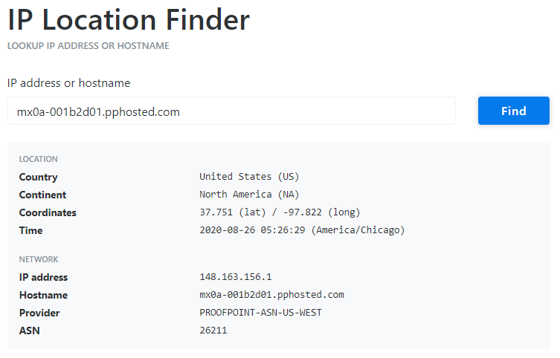

Address 2

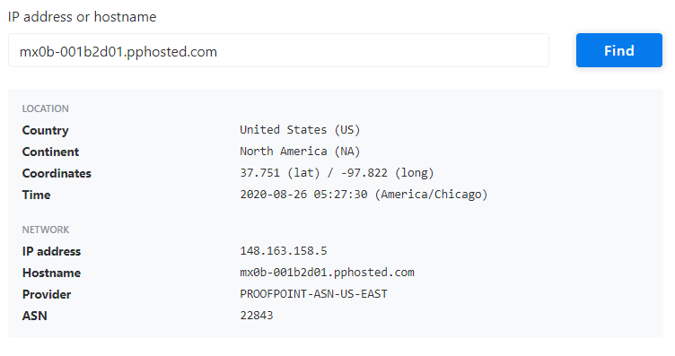

* Wipro.com

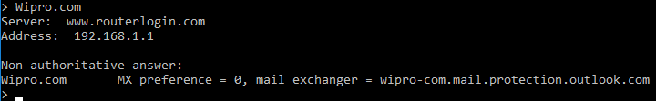

v.b.darshan200128@gmail.com

**Location**

Address

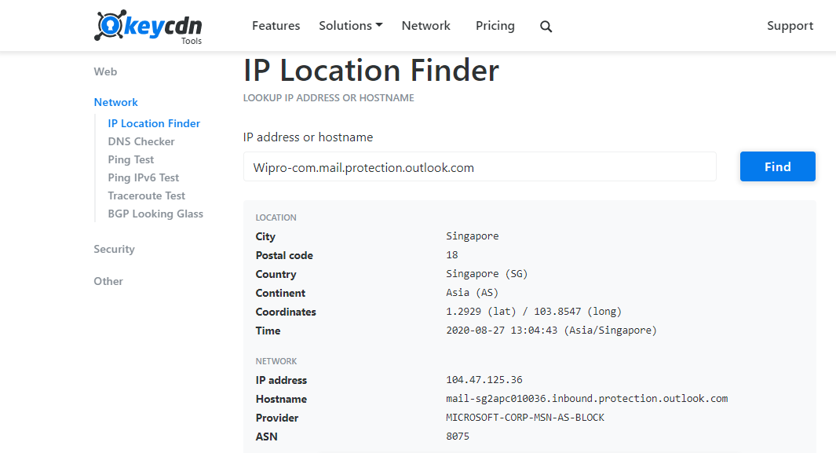

**Q3) Scan and find out port numbers open 203.163.246.23**

**Use -> Kali**

***Type***

* sudo su –
* Enter password
* nmap –Pn –sS 203.163.246.23

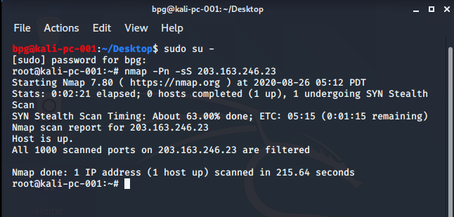

v.b.darshan200128@gmail.com

**Some extra alternative commands**

* -sS -v -v -Pn 203.163.246.23
* nmap -6 203.163.246.23
* nmap -p 22,25,135 -Pn -v –b 203.163.246.23 scanme.nmap.org
* nmap -vv -n -sS -Pn --ip-options "L 203.163.246.23 " --reason 203.163.246.23

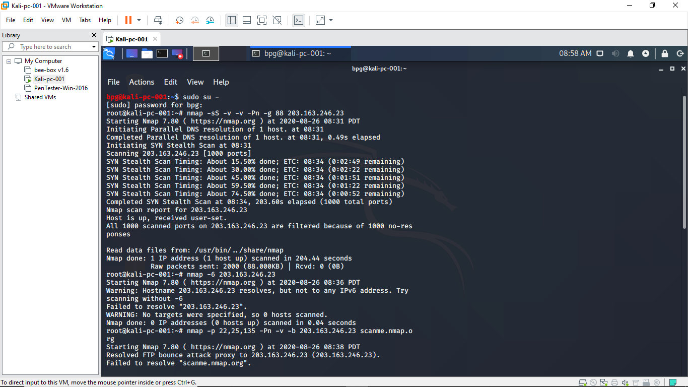

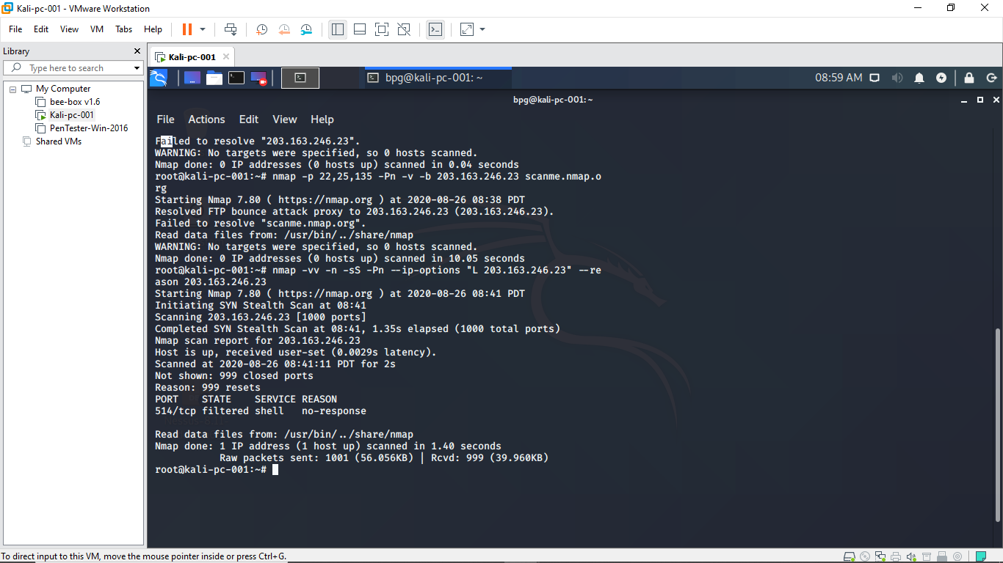

v.b.darshan200128@gmail.com

**Q4) Install nessus in a VM and scan your laptop/desktop for CVE**

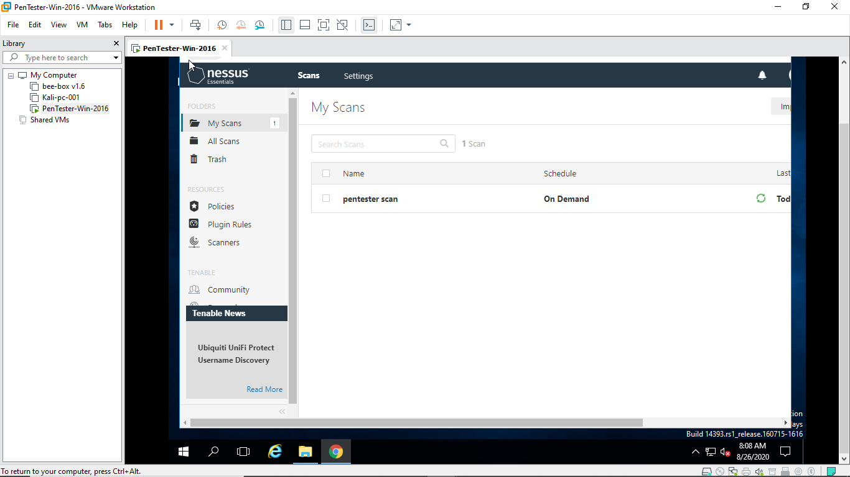

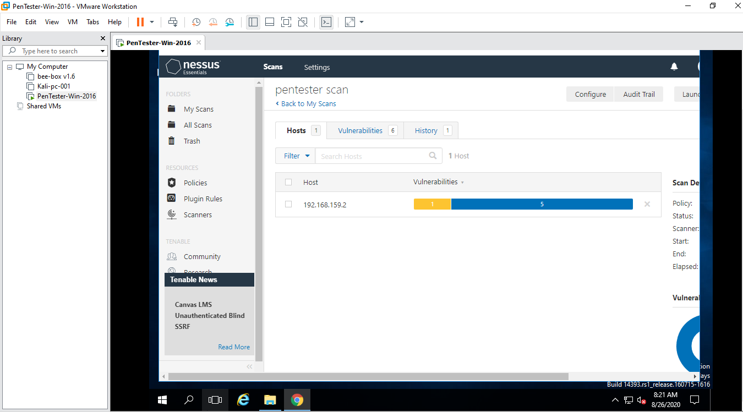

v.b.darshan200128@gmail.com

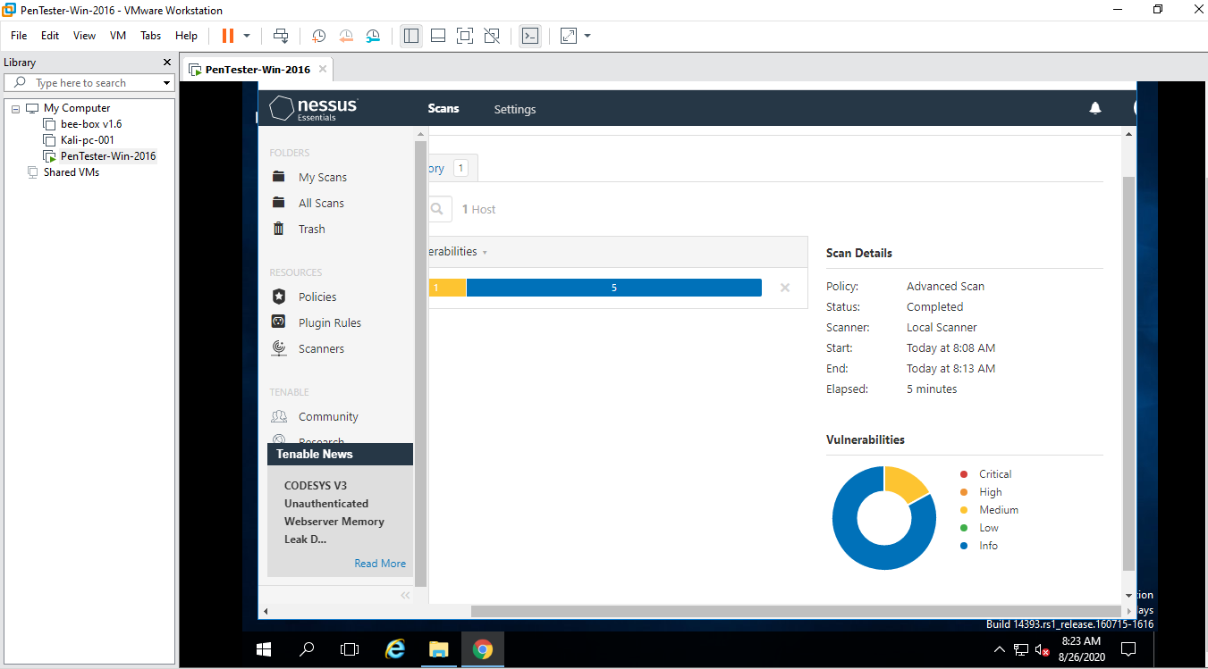

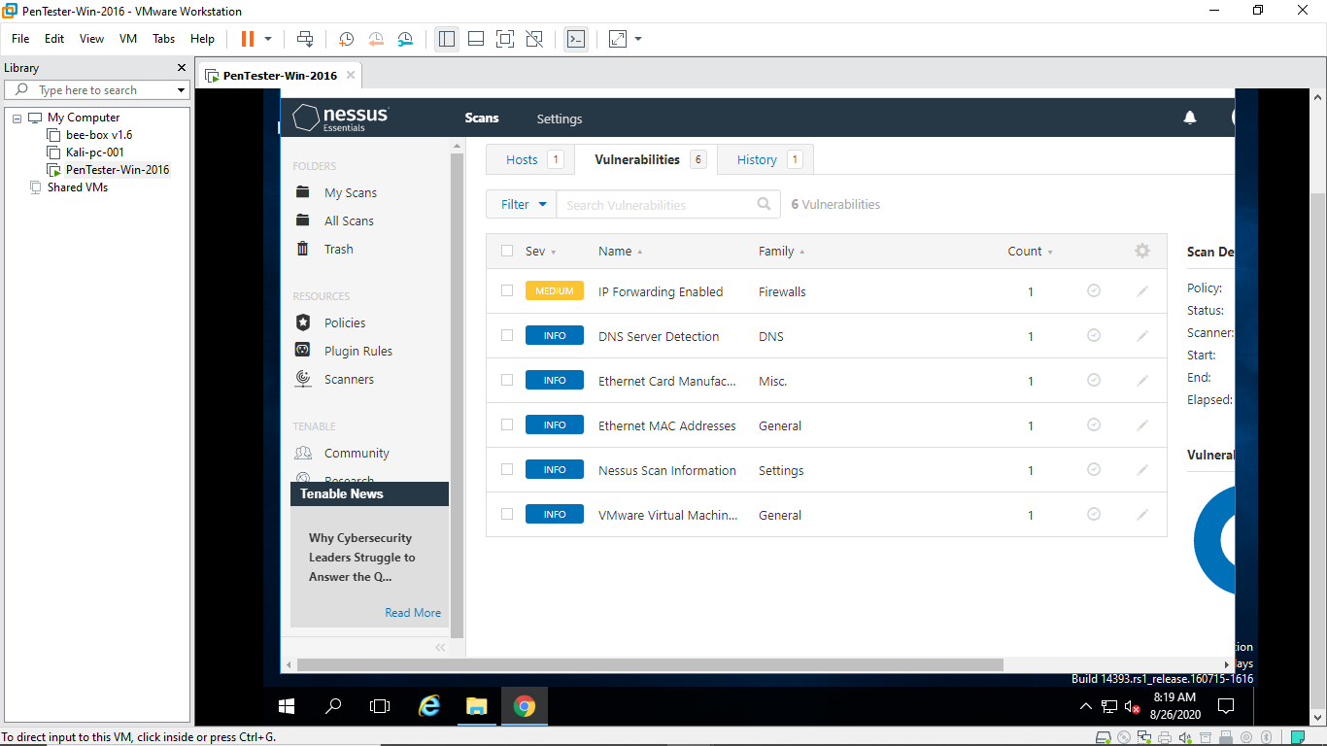

v.b.darshan200128@gmail.com

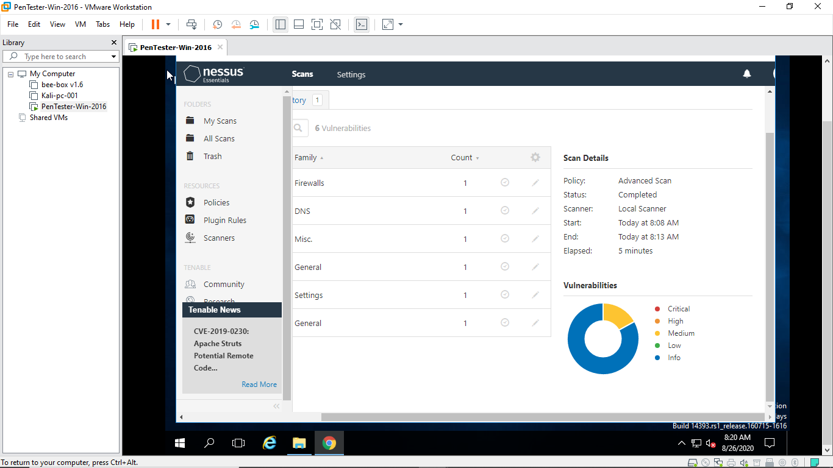

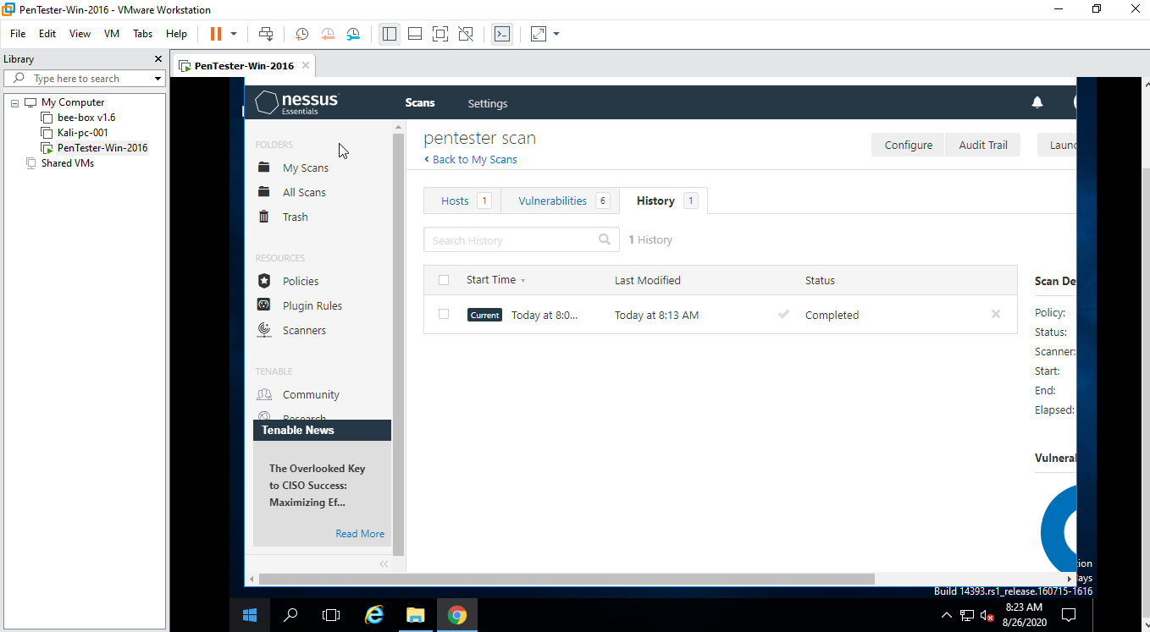 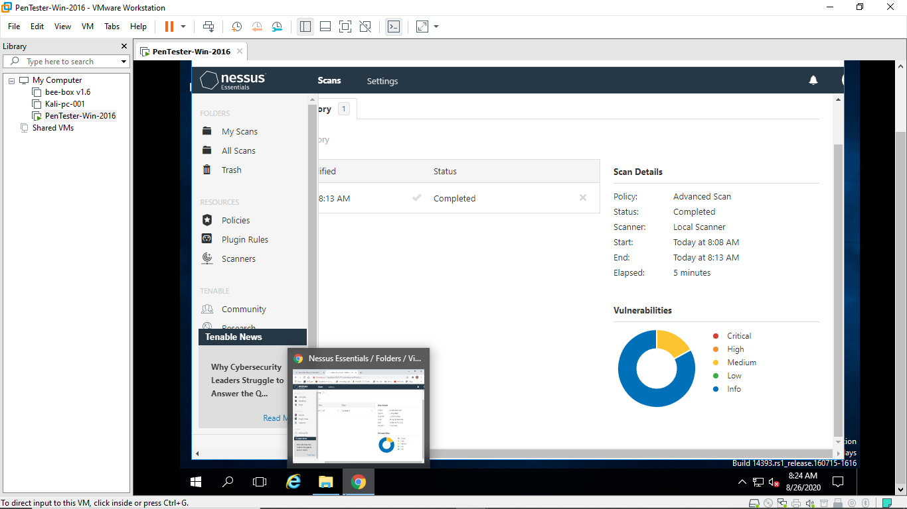

v.b.darshan200128@gmail.com